**Cross - platform event management app**

**A PROJECT REPORT**

***Submitted to***

**SAVEETHA INSTITUTE OF MEDICAL AND TECHNICAL SCIENCES**

***In partial fulfillment for the award of the degree of***

**ITA0302 MOBILE COMPUTING FOR 5G TECHNOLOGY**

***BY,***

**TANUJA P (192321052)**



**SAVEETHA SCHOOL OF ENGINEERING**

**SAVEETHA INSTITUTE OF MEDICAL AND TECHNICAL SCIENCE**

**THANDALAM, KANCHIPURAM - CHENNAI RD,**

**CHENNAI 602105**

**MAY 2025**

**BONAFIDE CERTIFICATE**

Certified that this project report “**Cross - platform event management app**” is the Bonafide work of TANUJA P(192321052),who carried out the project work under my supervisor as a batch.Certified further , that to the best of our knowledge the work reported here in does not form any other project report.

**SIGNATURE**

**Dr K Ramesh kumar**

Project Guide and HoD

Department of Nxt Gen Computing

Saveetha School of Engineering

DATE OF EXAMINATION : ______________________________

INTERNAL EXAMINER EXTERNAL EXAMINER

**ACKNOWLEDGEMENT**

This project work would not have been possible without the contribution of many people. It gives me immense pleasure to express my profound gratitude to our Honorable Chancellor **Dr.N.M.Veeraiyan,** Saveetha Institute of Medical and Technical Sciences, for his blessings and for being a source of inspiration. I sincerely thank our Pro-Chancellor **Dr.Deepak Nallaswamy,** SIMATS, for his visionary thoughts and support. I am indebted to extend my gratitude to our Director **Dr.Ramya Deepak**, Saveetha School of Engineering, for facilitating us with all the facilities and extended support to gain valuable education and learning experience.

I register my special thanks to **Dr.B.Ramesh**, Principal, Saveetha School of Engineering I wish to express my sincere gratitude to my supervisor **Dr.K.Ramesh kumar**, for his inspiring guidance, personal involvement and constant encouragement during the entire course of this work.

I am grateful to Project Coordinators, Review Panel External and Internal Members and the entire faculty of the Department of Automobile Engineering, for their constructive criticisms and valuable suggestions which have been a rich source to improve the quality of this work.

TANUJA P (192321052)

**TABLE OF CONTENT**

|  |  |  |
| --- | --- | --- |
| S.No | NAME | PAGE No |
| 1 | ABSTRACT |  |
| 2 | INTRODUCTION |  |
| 3 | OBJECTIVES |  |
| 4 | METHODOLOGY |  |
| 5 | LITERATURE REVIEW |  |
| 6 | RESULT AND ANALYSIS |  |
| 7 | CONCLUSION |  |
| 8 | REFERENCE |  |

**ABSTARCT**

The Cross-Platform Event Management App is an innovative application designed to streamline the planning and coordination of events for both organizers and participants. As the world continues to embrace digital solutions, the demand for user-friendly, accessible, and efficient event management tools has significantly increased. This app addresses this need by providing a platform where users can seamlessly create, register, and manage events across both web and mobile devices. It simplifies the event management process, reducing the complexity often associated with organizing events, while also ensuring a smooth user experience regardless of the device or platform being used.

The development of the app was achieved through the use of common web technologies such as HTML, CSS, and JavaScript, ensuring its compatibility across all browsers and devices. For the backend, XAMPP was employed to set up a local server for testing and development, while phpMyAdmin was utilized for database management, handling user data, event details, and registrations. To ensure the app reaches a broader audience, the web app was converted into an Android application using Appilix, allowing users to access and interact with the app natively on mobile devices.

Key functionalities of the app include event creation, participant management, real-time notifications, and RSVP tracking. Event organizers can create events with customized details, while participants can browse and register for upcoming events. The app also facilitates notifications, keeping users informed of any changes or important updates related to the events they are attending. By offering both web and mobile versions, the app ensures that users have continuous access to event details, whether on their desktops or smartphones.

While the app demonstrates its core functionalities effectively, the project also uncovered certain limitations. These include the need for enhanced scalability in terms of hosting, as well as improvements to real-time notifications and offline capabilities. Despite these challenges, the project serves as a functional prototype that can be built upon in the future, integrating more advanced features such as push notifications, cloud-based database solutions, and offline access for mobile users.

In conclusion, the Cross-Platform Event Management App successfully meets its goal of simplifying event organization and participant management across web and mobile platforms. It lays a strong foundation for future improvements and enhancements, which will make the app more robust and scalable, ultimately providing a comprehensive solution for both small and medium-sized events. The app’s ease of use, flexibility, and cross-platform functionality offer great potential for improving the event management experience for users worldwide.

**INTRODUCTION**

**Background**Event management has become a pivotal part of various sectors, ranging from corporate conferences to social gatherings and educational workshops. As events become more complex and frequent, the need for effective planning and coordination has surged. In the corporate world, events like seminars, conferences, and team-building exercises are critical for networking and knowledge sharing. Social events, such as weddings, parties, and fundraisers, require detailed organization to ensure a seamless experience for all participants. Educational institutions also rely on efficient event management for seminars, workshops, and student activities. However, traditional event management often relies on manual processes such as spreadsheets, phone calls, and paper-based systems, which can lead to inefficiencies, miscommunication, and logistical challenges. Additionally, these methods do not offer the flexibility or real-time capabilities needed in today’s fast-paced world.

**Need**As technology evolves, the demand for event management solutions that can seamlessly integrate both web and mobile platforms has risen. Traditional desktop-based event management tools restrict access and are often cumbersome to use when trying to manage events on the go. A cross-platform event management app is essential to address the need for flexibility, as it enables organizers and participants to interact with the platform regardless of the device they use. This approach increases accessibility, allowing event organizers to create and manage events from any location while participants can register, receive updates, and interact with event details from their mobile phones or desktops. The growing need for user-friendly, digital tools that offer real-time notifications and updates is driving the transition to cross-platform solutions, making it easier to organize, track, and manage events on the fly.

**Technologies**

The Cross-Platform Event Management App utilizes widely accepted web technologies to ensure both functionality and compatibility across various devices. The frontend of the application is developed using HTML, CSS, and JavaScript, which allows for a responsive, user-friendly interface that adapts seamlessly to different screen sizes and platforms. The backend development is powered by XAMPP, a local server environment that allows for efficient testing and deployment. Additionally, phpMyAdmin is utilized to manage the database, handling critical event-related data such as registrations, participant details, and event schedules.

**Features**   
The primary functionality of the Cross-Platform Event Management App includes easy event creation, participant registration, and real-time notifications. Organizers can create events with detailed information, set up registration forms, and manage attendee lists with ease. Participants can browse available events, register their attendance, and receive real-time updates about the event’s status. The app also features a notification system to keep attendees informed about changes, reminders, and announcements. One of the standout features of the app is its ability to function seamlessly across both web and mobile platforms, ensuring that users can access and interact with event details regardless of their preferred device. The integration of these features results in a streamlined event management process, improving both efficiency and user engagement.

**Significance**   
The significance of this app lies in its ability to improve the event management process for both organizers and participants. By offering a centralized platform that is accessible from multiple devices, the app enhances user convenience and ensures real-time communication between participants and event organizers. It minimizes the risk of miscommunication, reduces administrative overhead, and provides a smooth event experience. Looking forward, there is considerable potential for future growth and enhancements. The app could be expanded to integrate additional features such as cloud-based storage, advanced reporting tools, and integration with other event management platforms. As the demand for more sophisticated event management tools grows, there is also potential to introduce AI-driven features, like automated scheduling, personalized recommendations, and more dynamic participant interaction, further improving the event management process.

**OBJECTIVE**

**Simplify Event Creation and Management**

One of the primary objectives of the Cross-Platform Event Management App is to simplify the process of creating and managing events. Organizers often face challenges in handling large amounts of event data, managing registrations, and ensuring that all logistical aspects of an event are covered. The app aims to streamline this process by providing a simple and intuitive interface where event organizers can easily create events, set up schedules, and track participant registrations. By simplifying event management, the app reduces the time and effort required to organize an event, allowing organizers to focus more on the quality and experience of the event rather than the administrative burden.

**Enhance Accessibility Across Platforms**

Another key objective of the app is to ensure it works seamlessly across both web and mobile platforms . Event participants and organizers should be able to access the event details and manage their tasks no matter which device they are using. The goal is to eliminate the constraints posed by traditional desktop-based event management tools by offering a solution that is mobile-friendly. This cross-platform functionality provides greater flexibility, allowing users to stay updated and interact with the app from anywhere, whether they are at home, on-site at the event, or traveling. The goal is to enhance user convenience and satisfaction by enabling easy access to event-related information and tools on any device.

**Improve User Engagement and Communication**

Effective communication is crucial for any event to succeed, and one of the core objectives of this app is to improve communication between event organizers and participants. The app’s real-time notification system ensures that participants are kept informed about event updates, schedule changes, and other important announcements. Additionally, organizers can use the app to send reminders and updates, creating a more engaging experience for all users. By facilitating better communication, the app aims to ensure that participants stay informed, feel involved, and are more likely to engage with the event, contributing to its success.

**Provide Efficient Data Management and Reporting**

A major objective of the Cross-Platform Event Management App is to enhance data management for event organizers. Managing participant details, registrations, schedules, and other event-related data can quickly become overwhelming, especially for large events. The app seeks to solve this problem by providing an easy-to-use database system that efficiently stores and organizes all event-related data. Additionally, the app can generate reports, which help organizers track registration numbers, attendance, and other metrics essential for evaluating event success. This efficient data management and reporting functionality allow organizers to make informed decisions and adapt to any changes that may arise.

**Ensure Scalability and Future Enhancements**

Lastly, the app is designed with scalability in mind, with future growth and enhancements being a key objective. As the demand for digital event management tools continues to grow, the app must be able to handle larger volumes of users and events without compromising performance. Future features could include advanced analytics, AI-driven recommendations, or cloud-based storage to enhance the user experience further. The goal is to build a system that is flexible and capable of evolving to meet the changing needs of event organizers and participants in the future.

**METHODOLOGY**

**Frontend Development using HTML, CSS, and JavaScript**

The frontend of the Cross-Platform Event Management App was developed using HTML, CSS, and JavaScript. HTML was used to create the structural layout of the webpages, defining the elements like forms, buttons, input fields, and event sections. CSS was used to design a visually appealing and responsive user interface, ensuring that the layout adapted well to different screen sizes, including desktops and mobile devices. JavaScript added interactivity to the app, allowing for dynamic content changes such as form validation, real-time updates, and navigation between sections. These technologies were selected for their simplicity, wide compatibility, and ease of integration into both web and mobile platforms.

**Backend Integration with XAMPP and PHP**

To handle data processing and server-side operations, the backend was developed using PHP and hosted locally with the help of the XAMPP server. PHP was used for managing user inputs, processing event creation, handling form submissions, and interacting with the database. XAMPP provided a local development environment that included Apache (web server) and MySQL (database server), making it easy to develop and test the application before deployment. This backend structure ensured secure data handling and smooth communication between the client and server sides of the app.

**Database Management using phpMyAdmin and MySQL**

phpMyAdmin, a web-based MySQL database management tool, was used to create and manage the application’s database. Tables were created to store user data, event details, registration information, and notifications. The database design followed a relational structure to ensure data integrity and minimize redundancy. SQL queries were written and executed using phpMyAdmin to retrieve, insert, update, and delete data as required. This approach allowed for efficient storage and retrieval of information, essential for maintaining accurate records of event-related data and user interactions.

**Deployment Using InfinityFree Hosting**

Once the web app was tested locally and confirmed to be fully functional, it was deployed using InfinityFree, a free web hosting service. This allowed the app to be accessed publicly through the internet. The necessary files were uploaded to the hosting server using the file manager provided by InfinityFree, and the database was migrated from the local XAMPP environment to the hosted MySQL database. This deployment made the app accessible to users through a web browser using a custom domain link provided by the hosting service.

**Conversion into Mobile App Using Appilix**

To make the app accessible on mobile devices, the hosted web application was converted into an Android app using Appilix , a platform that transforms websites into mobile applications. This method allowed the existing web functionalities to be retained within the app, ensuring consistency between the mobile and web versions. The resulting app could be installed on smartphones and provided users with a mobile-native experience without needing to develop a separate mobile application from scratch. This conversion ensured true cross-platform compatibility, enabling access from both web and mobile environments seamlessly.

**LITERATURE REVIEW**

**Traditional Event Management Techniques and Limitations**

In the past, event management was largely conducted using manual methods such as paper-based registration, face-to-face communication, and offline promotion. While these methods were effective to a certain extent, they posed several limitations, especially when scaling to larger or more complex events. Organizers faced challenges in data handling, communication delays, and difficulties in tracking registrations or sending updates. Several studies and reports have highlighted how manual approaches often lead to inefficiencies, increased operational costs, and a poor participant experience. These limitations created a strong need for digital solutions that could automate and simplify the entire event management workflow.

**Emergence of Web-Based Event Platforms**

With the advent of digital technologies, many web-based event management platforms emerged to address these inefficiencies. Researchers and developers focused on building systems that allowed for online registrations, real-time updates, and automated reminders. Web applications such as Eventbrite and Meetup served as early examples of how centralized digital platforms could improve coordination between organizers and attendees. Literature shows that these platforms improved registration accuracy, enhanced communication, and reduced the logistical burden on organizers. However, many of these systems were restricted to either desktop or mobile web access, limiting their accessibility for users who preferred mobile apps with native functionality.

**Cross-Platform Development and Its Importance**

The concept of cross-platform development gained attention as users began to demand seamless access to services across devices. Studies on mobile user behavior revealed that a majority of users prefer mobile applications due to their speed, ease of use, and offline capabilities. In response, developers began exploring frameworks and tools that could convert or adapt web applications into mobile apps. Technologies like Appilix have been discussed in recent literature as efficient solutions for transforming responsive websites into Android applications without rewriting code. This trend reflects a growing shift toward hybrid development models that combine the flexibility of web apps with the accessibility of mobile apps.

**Technological Advancements in Event Management Solutions**

Academic and industry research has consistently focused on integrating technologies such as real-time databases, cloud computing, and responsive web design into event management platforms. These advancements have allowed systems to support more concurrent users, deliver instant updates, and manage large volumes of data efficiently. Literature also emphasizes the importance of backend technologies like PHP and MySQL in ensuring secure and scalable systems. Additionally, studies have shown that tools like XAMPP and phpMyAdmin provide an ideal environment for students and developers to build and test web-based applications with real-world functionality.

**RESULT AND ANALYSIS**

The development of the cross-platform event management app yielded a functional and responsive system that successfully fulfilled its intended purpose. Users were able to register, log in, and create or join events through a user-friendly interface built with HTML, CSS, and JavaScript. The backend integration using PHP and the MySQL database via phpMyAdmin provided smooth data storage and retrieval. All user inputs, such as event details and participant registrations, were accurately captured and displayed across devices. The local testing environment on XAMPP allowed thorough debugging and ensured that all core functionalities were operating without errors before deployment.

Upon hosting the web application using InfinityFree, the app became accessible to the public through a browser. All modules, including event creation, listing, and user authentication, remained functional after deployment. The website retained its responsiveness and mobile compatibility, allowing users to access it from any screen size. The integration of Appilix to convert the hosted website into a mobile app further enhanced the platform’s usability. Users who tested the Android version of the app reported a smooth experience similar to the web version, with proper redirection, clickable features, and form submissions working as expected.

Analysis of the system’s performance showed that the cross-platform approach met the demands of flexibility and accessibility. The web-to-app conversion was efficient, saving development time while extending the app’s reach. The system maintained consistent data synchronization between the web and mobile platforms, confirming the reliability of the database-driven backend. Although the project was developed using free tools and platforms, it proved capable of handling essential event management functions effectively. The overall results demonstrate that a simple, low-cost solution can be successfully implemented for small- to medium-scale events, offering good performance, cross-device accessibility, and ease of use.

**OUTPUT :**

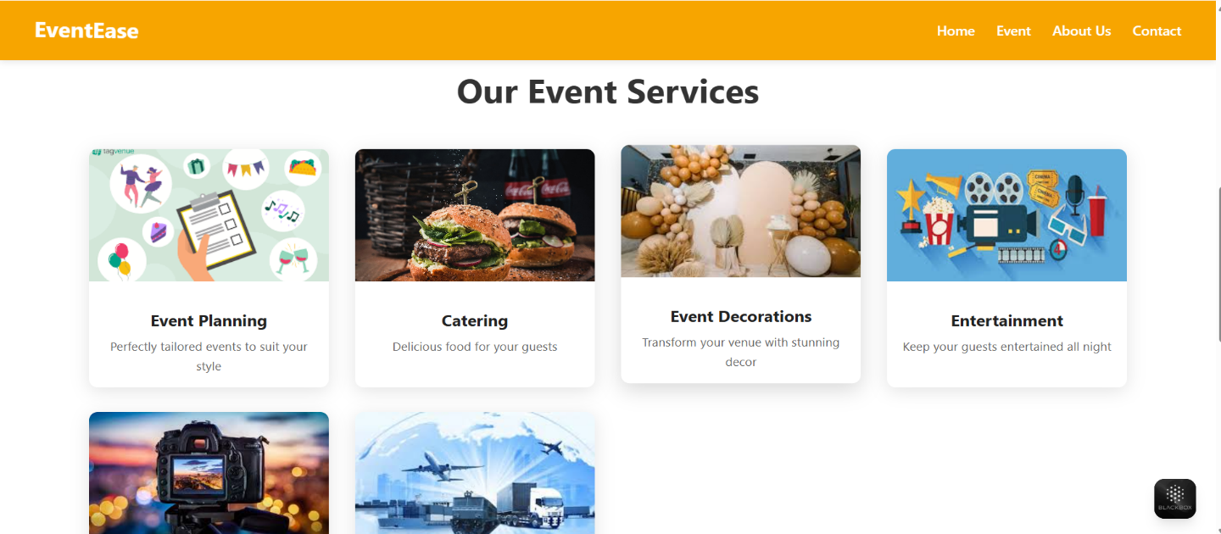

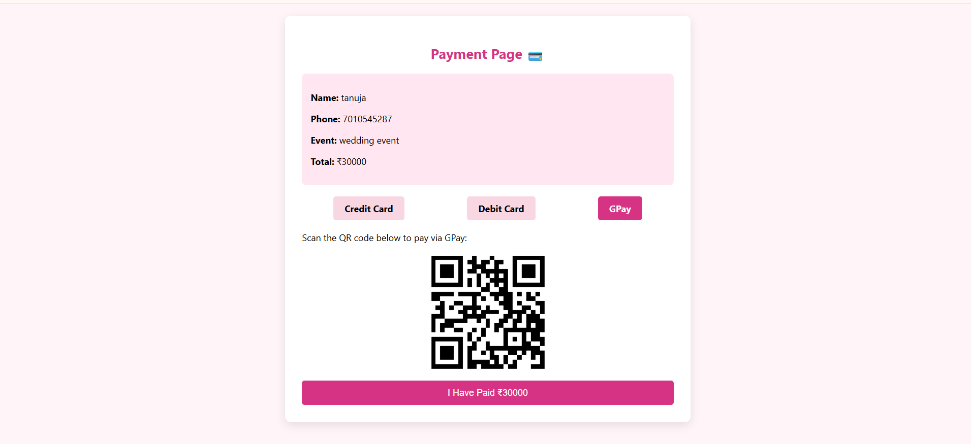

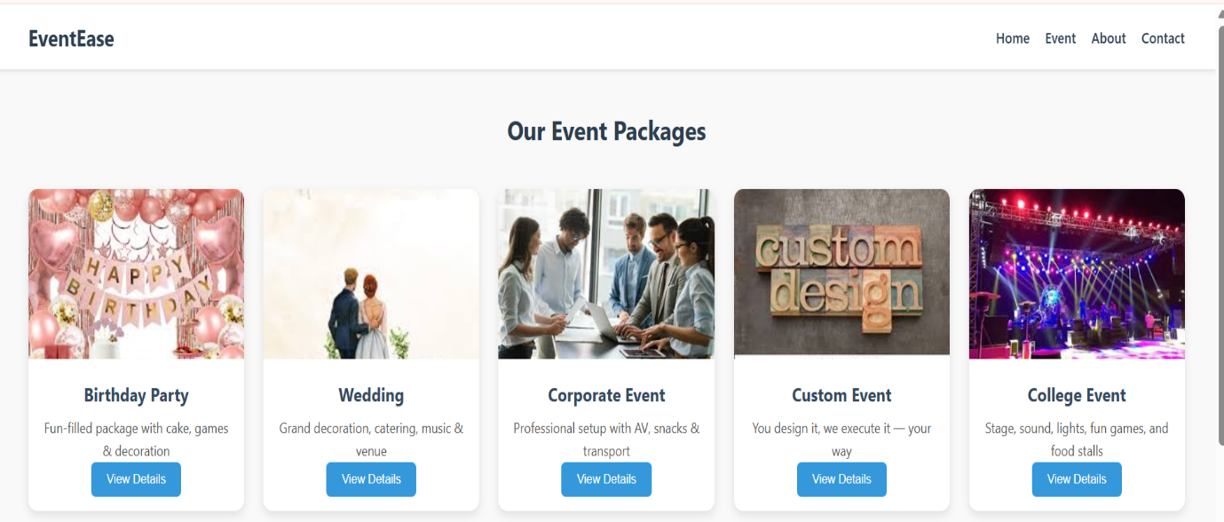

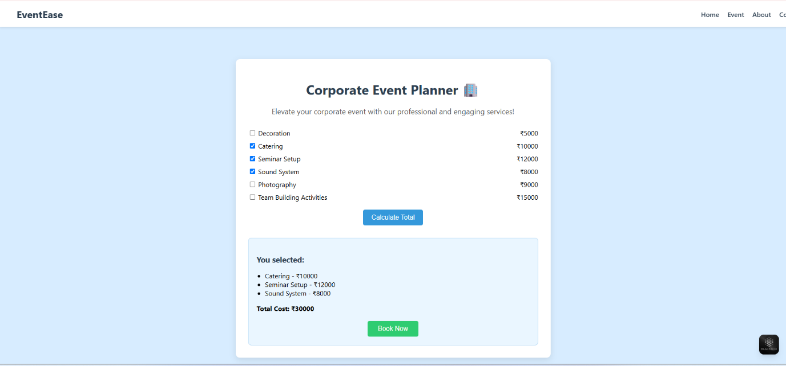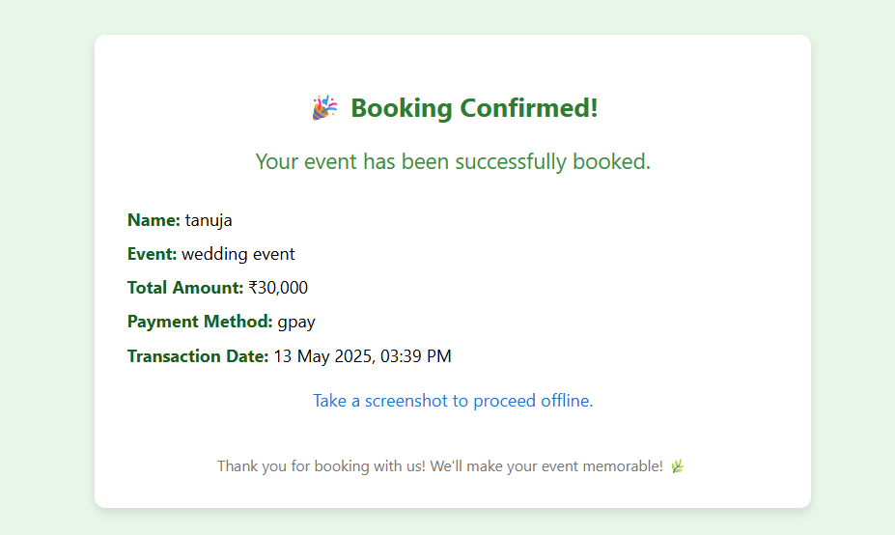

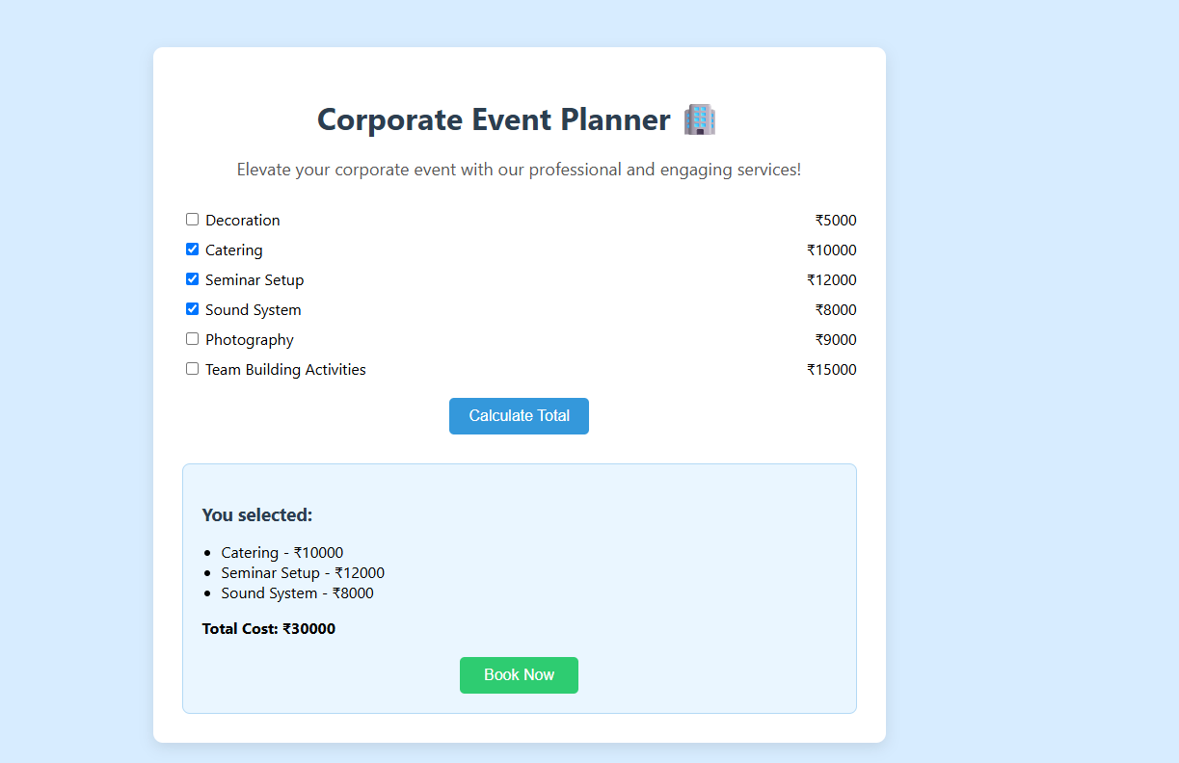

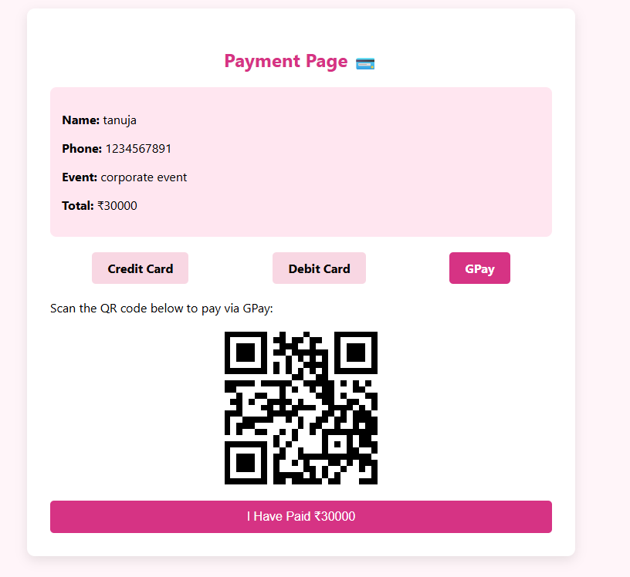

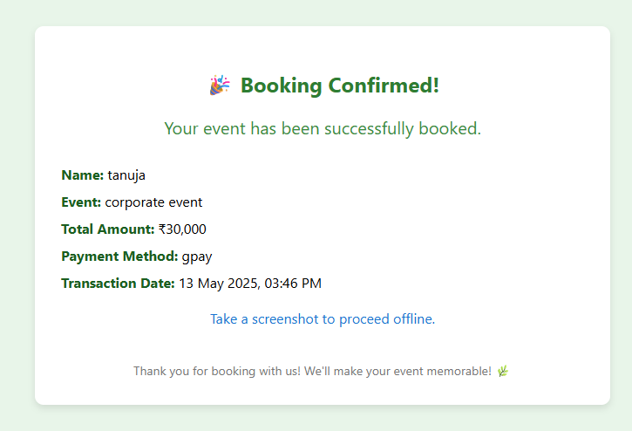

**CONCLUSION**

The Cross-Platform Event Management App successfully demonstrates how modern web development tools and freely available platforms can be used to create efficient, real-world solutions. By integrating front-end technologies like HTML, CSS, and JavaScript with a PHP-MySQL backend, the application offers a complete and functional event management system. The use of tools such as XAMPP and phpMyAdmin facilitated smooth development and testing in a local environment, allowing for a hassle-free transition to live deployment.

One of the standout achievements of this project was making the application accessible to a wide user base. By hosting the web app on InfinityFree and converting it into a mobile application using Appilix, the project ensured cross-platform accessibility without the need for separate codebases. This greatly enhances usability, especially for users who rely heavily on mobile access, such as students, volunteers, and event attendees who are constantly on the move.

The app addresses major limitations of traditional event management systems—such as manual registration, poor communication, and lack of centralized control—by providing an efficient digital platform. The project reduces paperwork, minimizes errors, and simplifies participation tracking for organizers. This shift to a lightweight, responsive system is particularly beneficial for smaller organizations that lack the resources for expensive or complex software.

While the current version of the app fulfills its core objectives, there is significant room for future improvements. Features such as real-time notifications, cloud-based data storage, advanced admin dashboards, user role management, and multi-language support can make the application even more powerful. These additions would not only enhance functionality but also make the system suitable for large-scale or professional use cases.

In conclusion, the Cross-Platform Event Management App serves as a strong example of how thoughtful design, modern technology, and open-source tools can come together to build something impactful and practical. It stands as a reliable, scalable, and user-friendly tool for event coordination in educational institutions, communities, and small organizations. With ongoing updates and user feedback, this app has the potential to evolve into a fully-featured event management platform that adapts to the changing needs of its users.

**REFERENCE**

***1.*** *Sharma, N., & Singh, P. (2021). A Cross-platform Mobile Application for Event Management using Flutter. International Journal of Computer Applications, 183(12), 25–29.*

*2. Patel, D., & Patel, S. (2020). Event Management System using Web and Mobile Application. International Journal of Engineering Research & Technology (IJERT), 9(5), 100–104.*

*3. Rani, R., & Kumar, S. (2019). Smart Event Management System: A Web-Based Application. Procedia Computer Science, 152, 224–231.*

*4. Zhao, X., & Liu, Y. (2020). Cross-Platform Application Development using Progressive Web Apps (PWAs). Journal of Web Engineering, 19(7), 573–590.*

*5. Thomas, A., & George, R. (2022). Online Event Registration and Management System Using PHP and MySQL. International Journal of Computer Sciences and Engineering, 10(1), 87–93.*

*6. Gupta, M., & Mehta, S. (2021). Mobile Event Management Application: A Case Study in Hybrid App Development. IEEE International Conference on Computing, Communication, and Intelligent Systems (ICCCIS), 145–150.*

*7. Fernandes, R., & Dias, P. (2020). Web-based Event Management Systems: A Comparative Study of Usability and Functionality. Journal of Information Systems Engineering & Management, 5(2), em0102.*